

My visit to the Portland Library

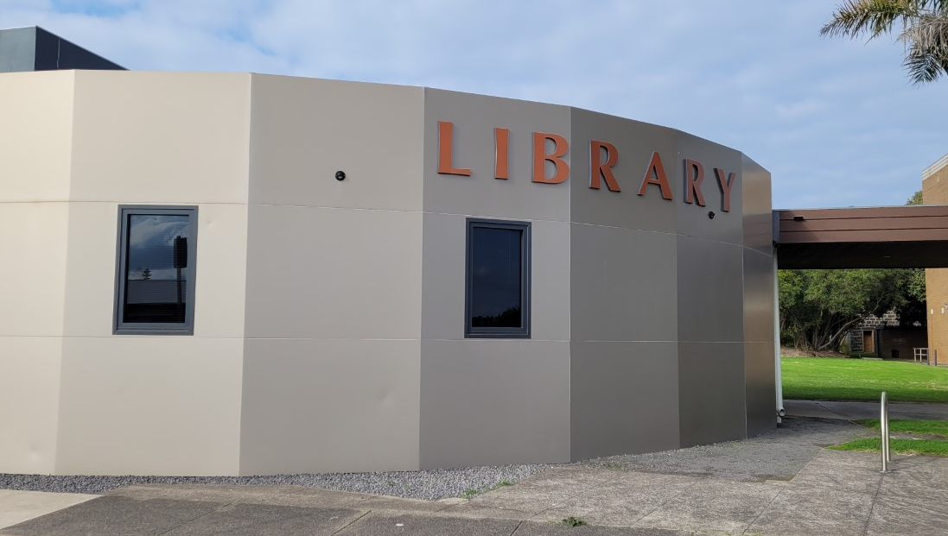

I am going to the library. The library is a safe space to visit.

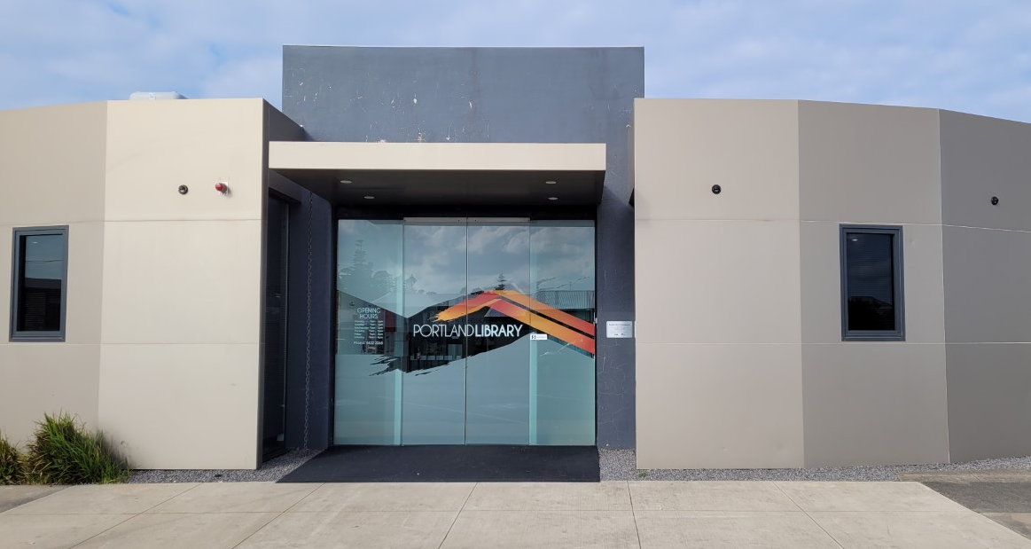

I walk through the front glass sliding doors into the entrance.

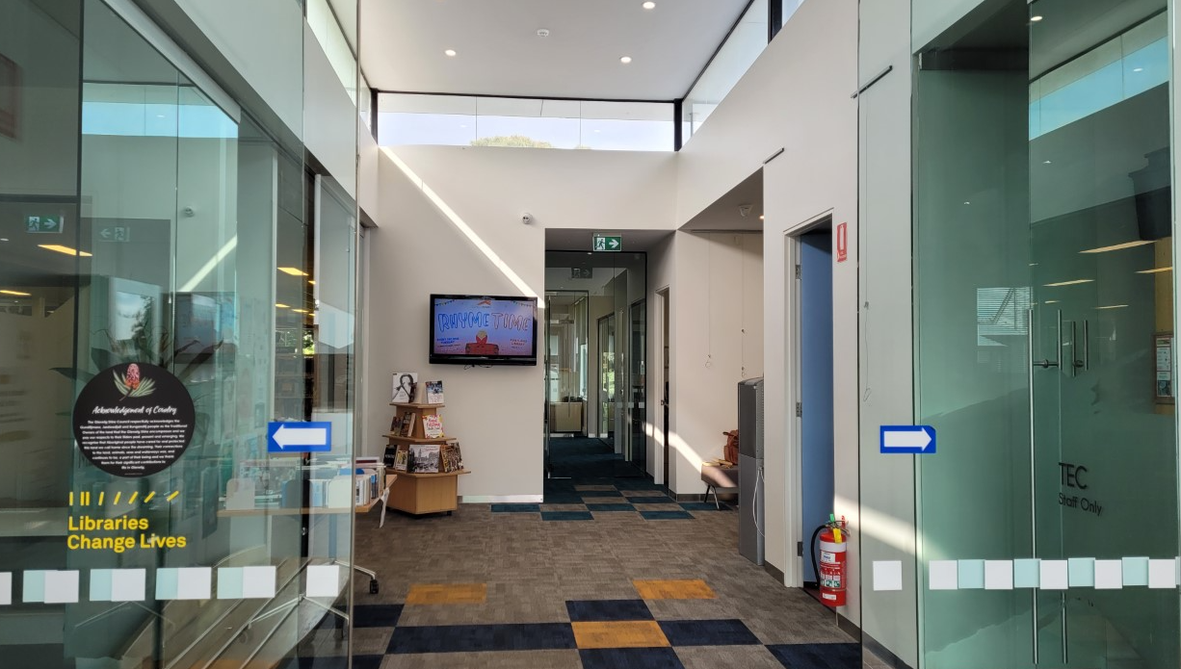

Here I can look at and read books and magazines. I can also listen to audio books or music and I can use the computers. There is art work to look at and there are games to play, or I can just relax.

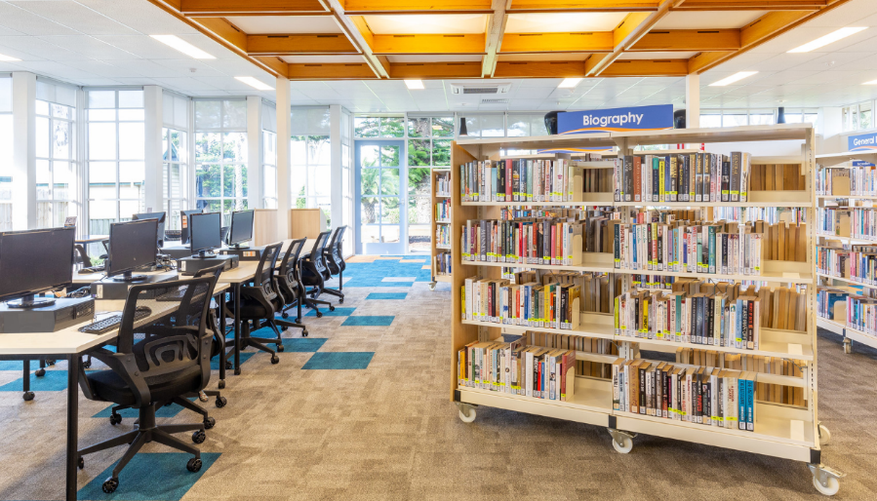

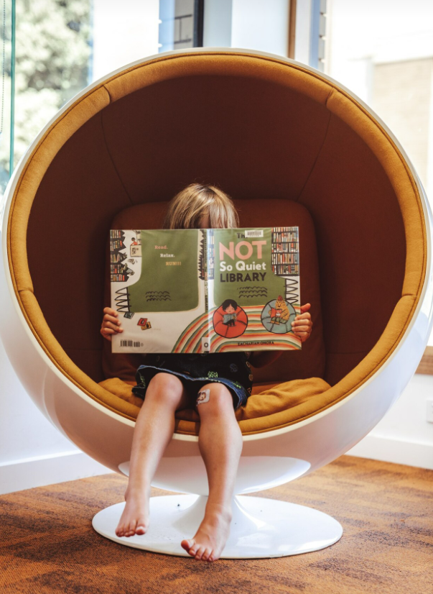

‘

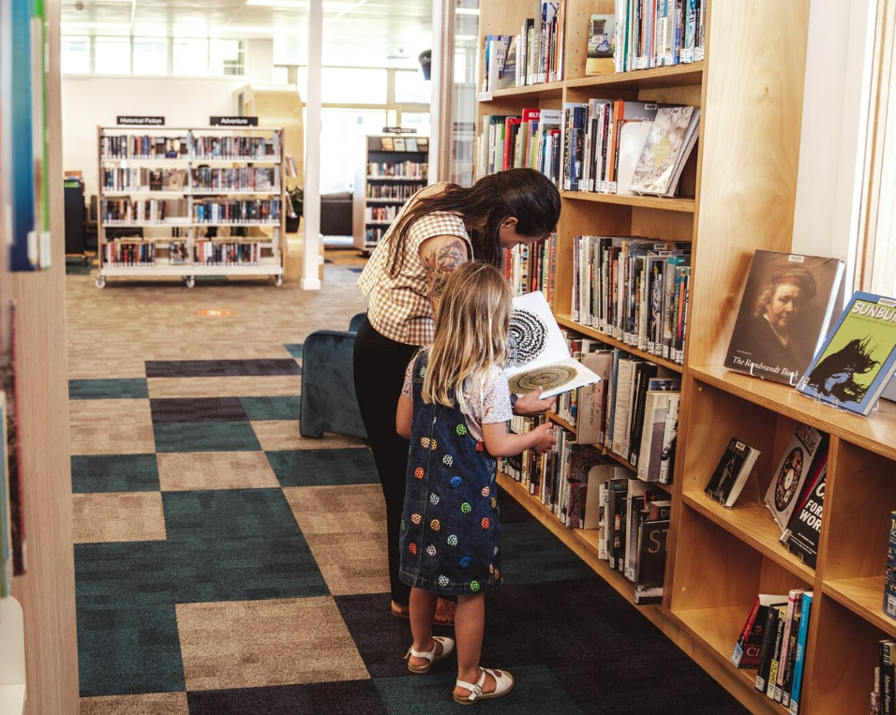
There are people who work at the library. They are called Library Services Officers. They wear a name badge. I can ask them questions about what I can do and see at the library.

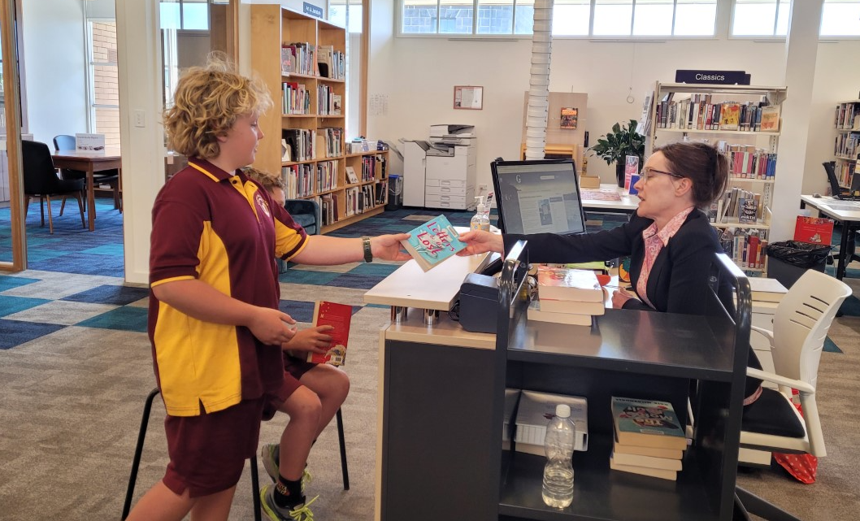

At the Library there can be lots of children and babies. They visit the library because it is a fun and safe meeting place. Sometimes it can get loud. This is okay, they are all having fun and I am safe.
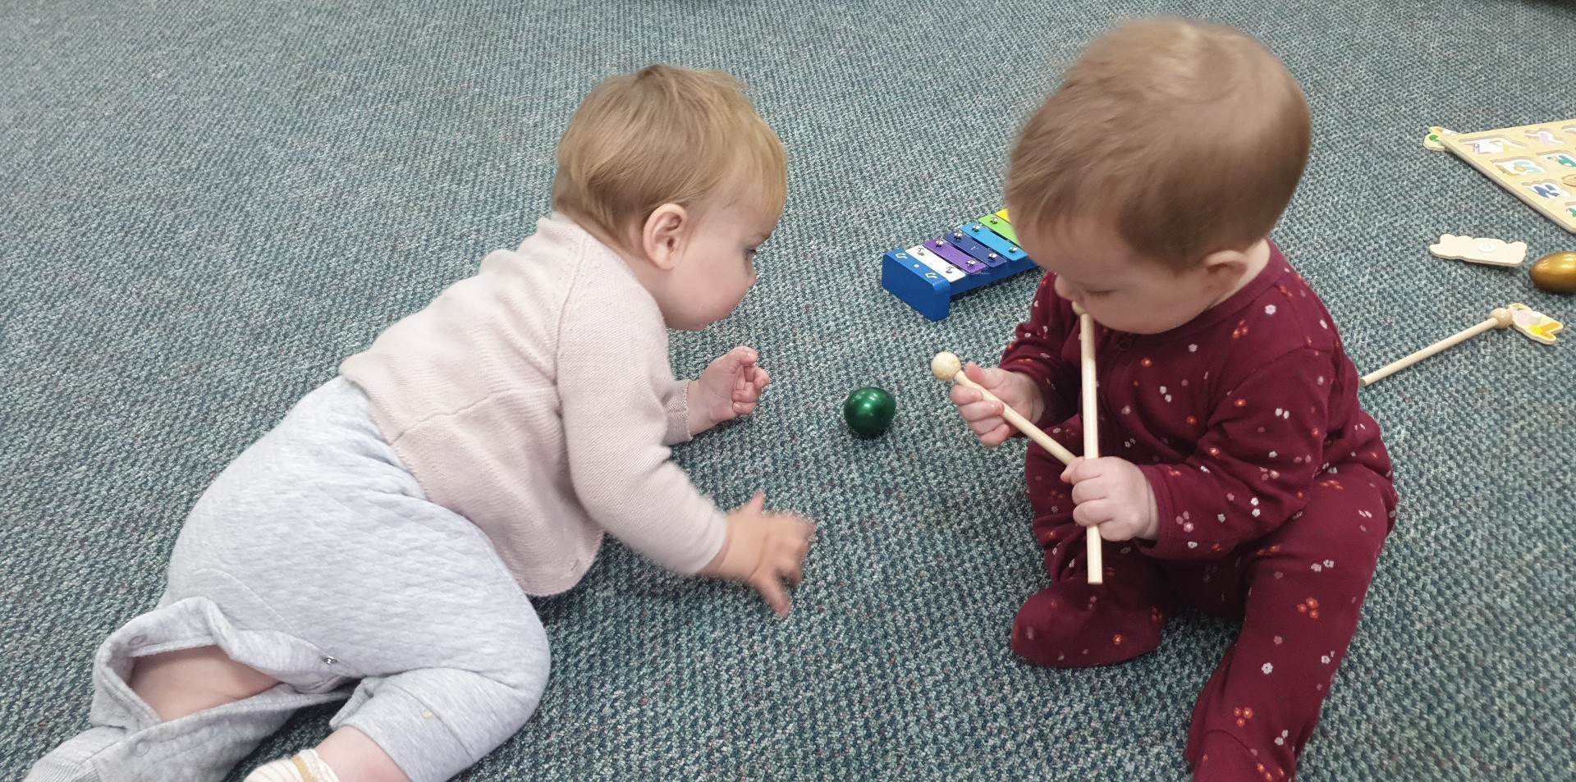

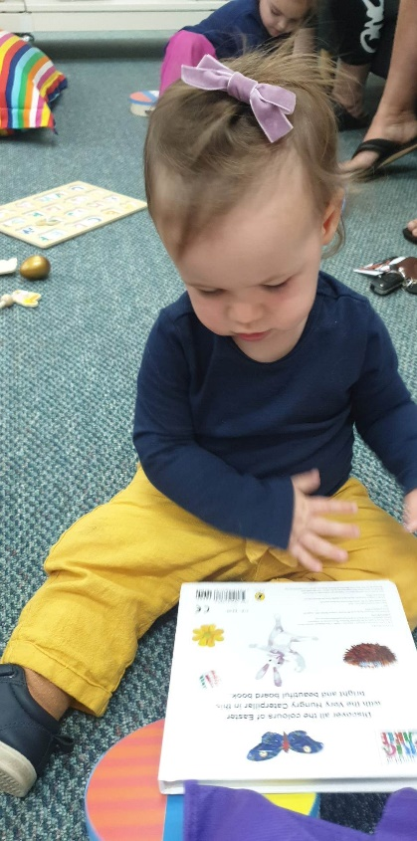
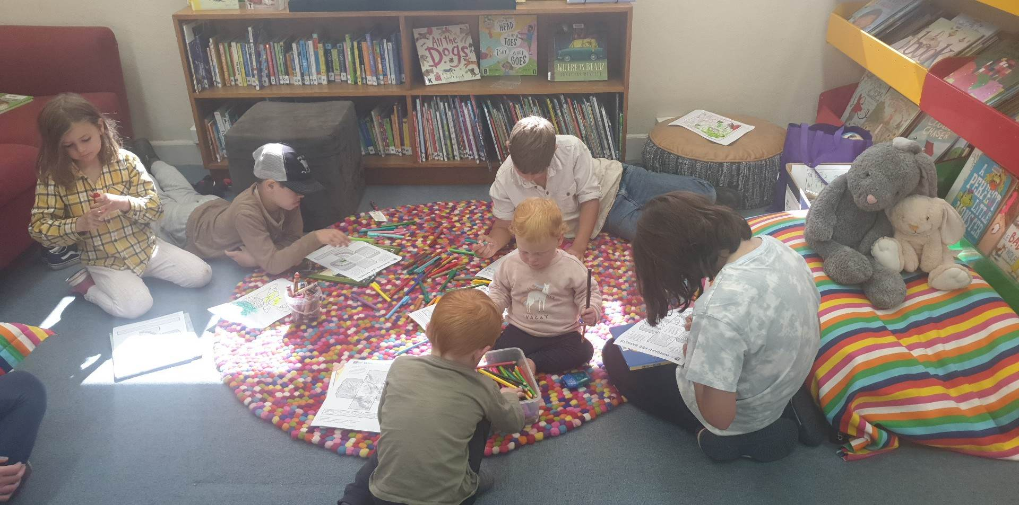

Outside the library is a decking area and a grassed area. I am allowed to sit outside to read my books.

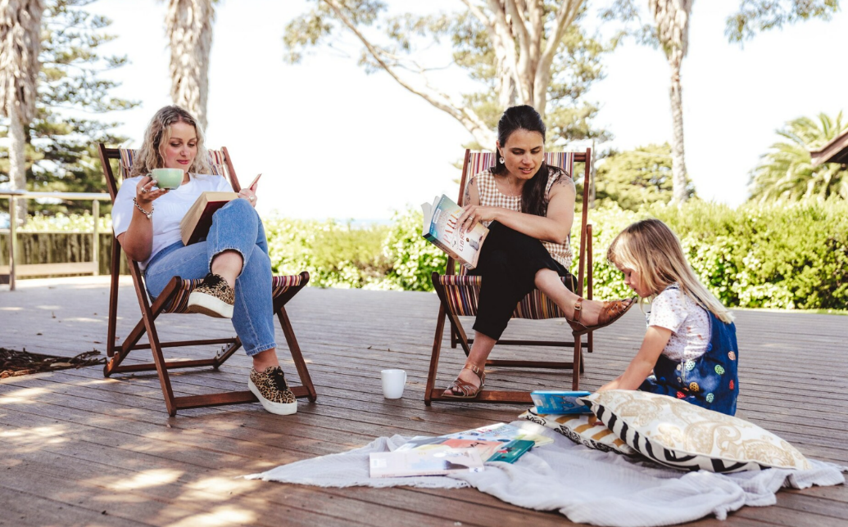
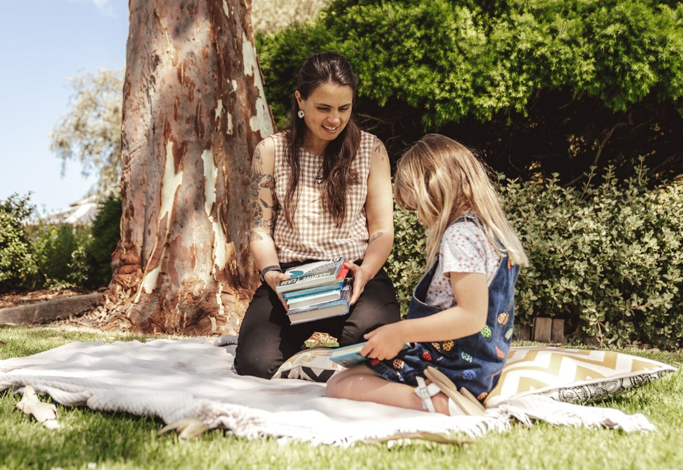

There are toilets at the library. If I need to go to the toilet, I need to tell my support.

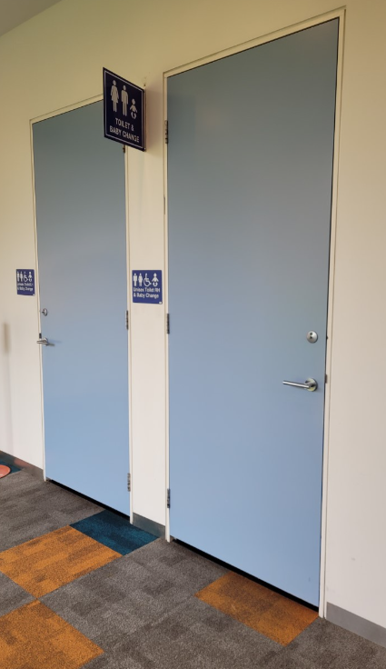
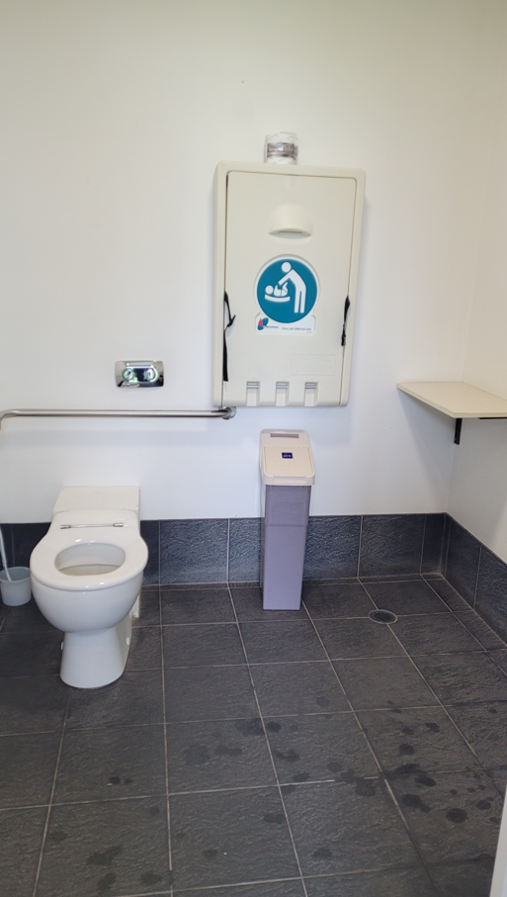

I had fun searching through the books and looking at all there is to do at the Portland Library.

